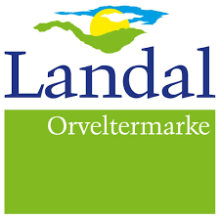
Dear Guest,

During the Dutch Balloon Trophy event we can offer multiple catering options. Below you can find the different options. You can make a reservation until the 1st of May by e-mail orveltermarke@landal.com or call 0593-564100.

Breakfast (in the bungalow):
2 pieces of bread and 1 croissant
Boiled egg and salt, Coffee or tea , Sugar
Jam, Cheese, Cold cuts, Butter
Chocolate sprinkles, Vitamin juice or Orange juice, Cup of yogurt
€12,50 per person

Shared Dining:
Changing menu, varied and healthy.
Excl. drinks
From 16.30 until 17.30
€ 22,50 per person

Day 1 – May 28th
Mini schnitzels with mushroom cream sauce
Salmon with chimichurri
Potato gratin
Warm vegetables (broccoli/cauliflower)
Green salad

Day 2 – May 29th
Chicken chops with barbecue sauce
Marinated prawns
French fries
Grilled vegetables
Green salad

Day 3 – May 30th
Boeuf Bourguignon
Cod with roasted cherry tomatoes
Fried potatoes
Warm vegetables (endive/haricots verts)
Green salad

Day 4 – May 31th
German steak with fried onions
Sole stuffed with salmon
Spicy wedges
Oven-baked carrots
Green salad

